**Hosting a Static Portfolio Website on S3:**

**Objective**: Learn to host a static website (such as a personal portfolio) on Amazon S3.

**Approach**:

1. **Create an S3 Bucket**: Start by creating a new S3 bucket. Configure the bucket for website hosting, which includes setting permissions to make the content publicly accessible.
2. **Upload Website Files**: Upload the static files of your portfolio website (HTML, CSS, JavaScript, images) to the S3 bucket.
3. **Configure DNS**: Use Amazon Route 53 or another DNS service to point a domain name to the S3 bucket. This makes the website accessible via a user-friendly URL.
4. **Enable Additional Features** (Optional): Implement features like HTTPS for secure access and CloudFront for content delivery optimization.

**Goal**: Students will understand how to use S3 for hosting static websites, manage bucket permissions, and integrate with other AWS services for a complete web hosting solution.

Steps:

1)create a s3 bucket

2)add website file into it

3)then edit static web-site hosting setting

4)edit bucket policy

5)generate the policy for bucket

6) make sure that your able to access static website using url

Step 1: Create an s3 Bucket

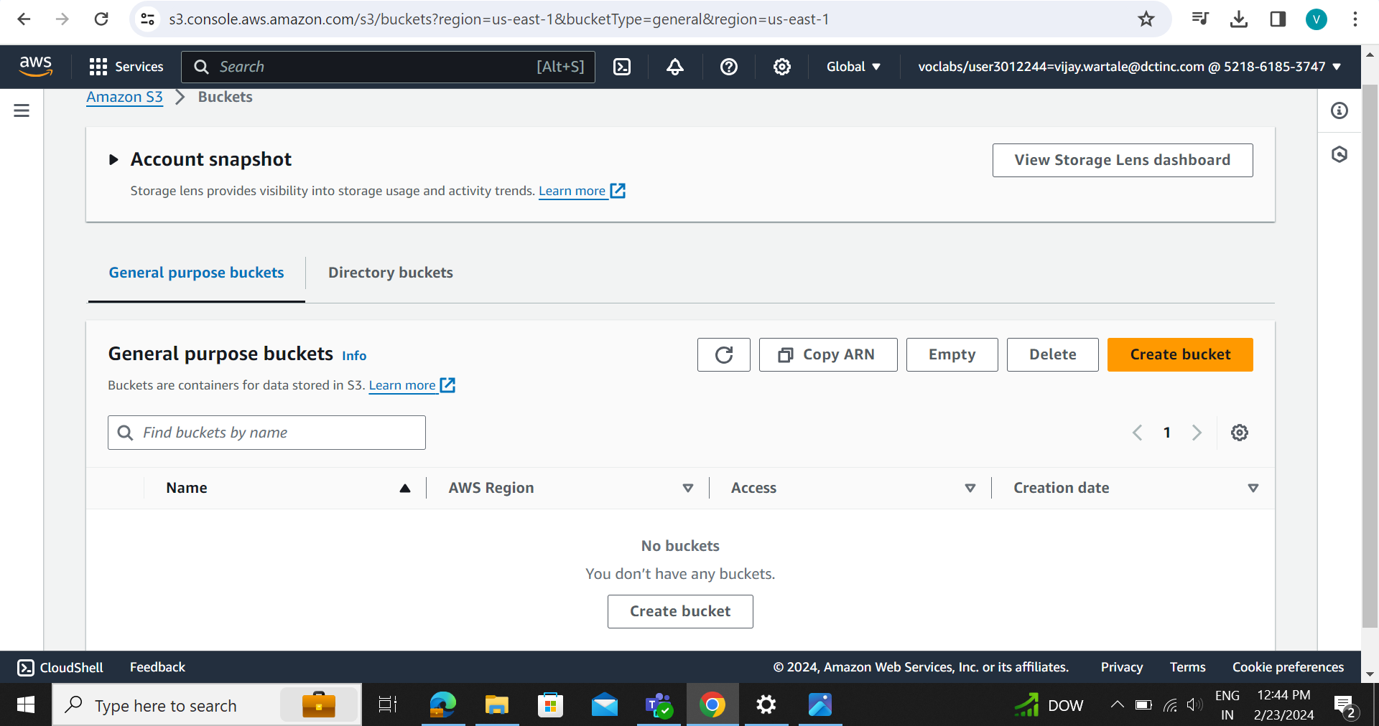

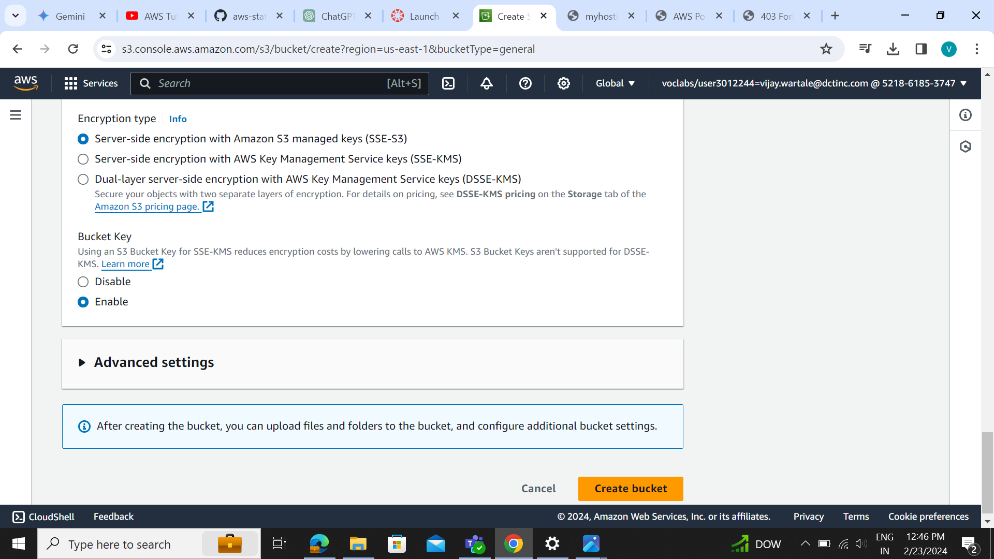

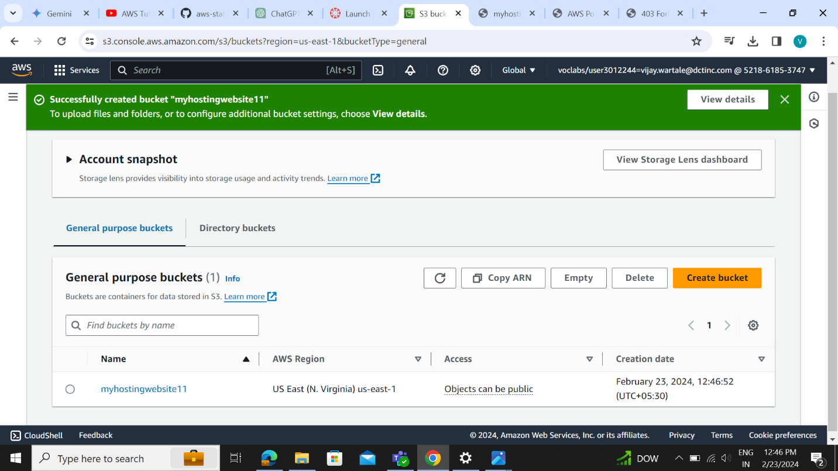

1. Upload Website files into s3 bucket



